Status Report:
Holey Moley

Huning "David" Dai (dai@cs.columbia.edu)

Michael Glass (mgg2102@columbia.edu)

Advisor: Herbert Hugh Thompson

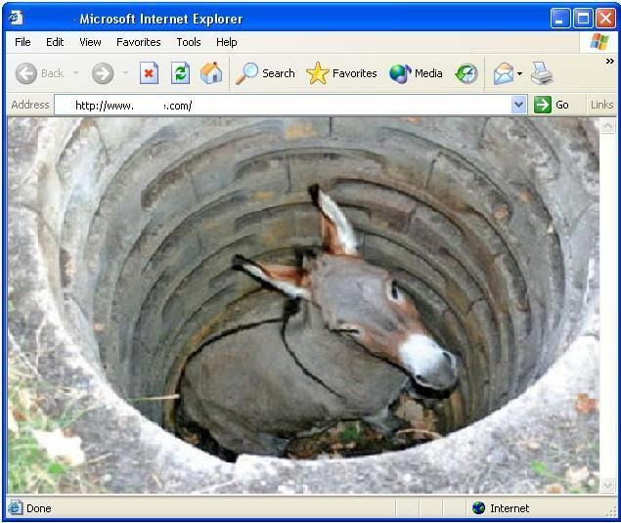

1. Introduction:
As the Internet has grown in popularity, security vulnerability detecting and testing are undoubtedly becoming crucial parts for commercial software, especially for web service applications. Vulnerability scanners, both commercial and open-source (i.e., Rational AppScan, WebInspect, AcuSensor, etc.), were developed to achieve this goal. However, the absence of an assessment benchmark makes the efficient evaluation of these scanners nearly impossible. With ongoing researches on new vulnerability scanners, the demand for an assessment benchmark is urgent.
For this project, we will define a minimal standard (baseline) for web security testing tools by systematically seeding selected vulnerabilities into a test website and then measuring how the tools being evaluated discover them. To achieve this, we will develop a methodology of defining the baseline, a simple web-based scanner-facing UI, and a framework for developing systematically injected vulnerabilities.

2. Objectives:
We divide our project into two parts:
First, we have to develop a method of defining a baseline for web security scanners. The baseline is represented by a set of vulnerabilities that any legitimate web security scanners should be able to detect.

Second, given the baseline (a set of vulnerabilities), we have to develop a framework that can systematically inject these vulnerabilities into a test website. Each vulnerability will contain a state machine with edges composed of tests against effective (or ineffective) known attack methods. Scanner effectiveness will be gauged based on overall number of successful attack vectors found.

3. Defining the baseline
3.1 Problem Definition
The major question is: which vulnerabilities we should choose to represent the smallest set of vulnerabilities that should be detected by web vulnerability scanners. One idea will be collecting all the claims made by both commercial and open-source web vulnerability scanners to find out the most common vulnerabilities that are said to be detectable by most of the scanners. However, a baseline generated by this idea might not be fair, because different products always tend to target different types of vulnerabilities which means they might be strong in detecting some vulnerabilities while weak in detecting the others. Also when we try to collect the claims from each well-known product, a considerable percentage of them do not have a list of vulnerabilities that they are able to detect. This will impede the legitimacy of the baseline greatly.

3.2 Approach
In order to deal with these problems, we come up with a real-time metrics using the standardized Common Weakness Enumeration (CWE) together with the always up-to-date U.S. government repository of vulnerabilities (NVD). Our idea is to maintain a dynamic ranking of both the average CVSS score and the number of occurrence in a given date range for every weakness (aka. vulnerability) in CWE. We were surprised at the fact that there was no such ranking system for vulnerabilities after spending a long time searching on the Internet, thus we decided to implement one. A live ranking system of the vulnerabilities has a lot of merits. First of all, it provides us a more explicit view of the impact of different vulnerabilities. Second, it helps to find the trend of vulnerabilities and give suggestions of prevention. Furthermore, it serves as the most reasonable criteria in defining a baseline for vulnerability scanners.

3.3 Implementation
We used a database to keep all the data and generates the ranking upon request, the database updates itself whenever new feed is available on CWE and NVD. Some of the details are as follows:

For CWE, we maintain two tables in the database:
CWE table:
ID (corresponding to CWE id)
name (weakness name)
type (integer, weakness can be category, view, weakness, or compound_element)
count (number of weaknesses found in NVD table, including all descendants)
score (average score of all descendant weaknesses in NVD table)
Because we have to keep the parent and child relationship between weaknesses, we created a join table:
CWE Join table
ID (system generated id)
parent_id
child_id
For NVD, we keep a table of all vulnerabilities:
NVD table:
ID (corresponding to NVD id)
weakness_id (corresponding to CWE id)
score (CVSS score)
published (timestamp)
modified (timestamp)

After the database is populated, we can easily generate the rankings of vulnerabilities based on the number of occurrence and the average CVSS score. With this two rankings, we designed a weight-based formula to calculate the baseline. Assume that we want to take a set of N representative vulnerabilities as the baseline. And T is the number of entries in the CWE table, which is 810 at the time we write this report, corresponding to the number of different types of vulnerability. We define a count_score for each vulnerability in CWE. The count_score for the vulnerability can be calculated with:
count_score = count_rank * 10 / T
In which the count_rank of the vulnerability with the least number of occurrence is 1 and the count_rank of the most common vulnerability is T.

Using the count_score together with the cvss_score (average CVSS score of all descendant weaknesses in NVD table), we can derive the final_score of a vulnerability in CWE with this formula:
final_score = count_weight * count_score + cvss_weight * cvss_score
Note: count_weight+ cvss_weight = 1

Finally, we get the ranking of all vulnerabilities order by the final_score and take the top N vulnerabilities as the set of vulnerabilities representing the baseline.

3.4 Test Results
The Top 10 most common vulnerabilities 2002-2010 (order by count_score):
CWE-ID | Name | Count | Avg.Score
89 | Improper Sanitization of Special Elements used in an SQL Command ('SQL Injection') | 2528 | 7.37405
79 | Failure to Preserve Web Page Structure ('Cross-site Scripting') | 2218 | 4.24536
119 | Failure to Constrain Operations within the Bounds of a Memory Buffer | 1815 | 8.22132
264 | Permissions, Privileges, and Access Controls | 1251 | 6.33941
94 | Failure to Control Generation of Code ('Code Injection') | 1083 | 7.69732
20 | Improper Input Validation | 1030 | 6.51184
22 | Improper Limitation of a Pathname to a Restricted Directory ('Path Traversal') | 943 | 6.44464
399 | Resource Management Errors | 707 | 6.7512
200 | Information Exposure | 523 | 4.90841
287 | Improper Authentication | 462 | 7.10087

The Top 10 most dangerous vulnerabilities 2002-2010 (order by cvss_score):
CWE-ID | Name | Avg.Score | Count
78 | Improper Sanitization of Special Elements used in an OS Command ('OS Command Injection') | 8.26562 | 32
119 | Failure to Constrain Operations within the Bounds of a Memory Buffer | 8.22132 | 1815
94 | Failure to Control Generation of Code ('Code Injection') | 7.69732 | 1083
189 | Numeric Errors | 7.50741 | 459
134 | Uncontrolled Format String | 7.4093 | 86
89 | Improper Sanitization of Special Elements used in an SQL Command ('SQL Injection') | 7.37405 | 2528
287 | Improper Authentication | 7.10087 | 462
399 | Resource Management Errors | 6.7512 | 707
20 | Improper Input Validation | 6.51184 | 1030
22 | Improper Limitation of a Pathname to a Restricted Directory ('Path Traversal') | 6.44464 | 943

Applying the formula with count_weight = 0.5 and cvss_weight = 0.5 gives us:
The Top 10 vulnerabilities 2002 - 2010 (order by final_score):
CWE-ID | Name | Avg.Score | Count | final_score
89 | Improper Sanitization of Special Elements used in an SQL Command ('SQL Injection') | 7.37405 | 2528 | 8.687025
119 | Failure to Constrain Operations within the Bounds of a Memory Buffer | 8.22132 | 1815 | 8.58416
94 | Failure to Control Generation of Code ('Code Injection') | 7.69732 | 1083 | 7.79616
264 | Permissions, Privileges, and Access Controls | 6.33941 | 1251 | 7.380205
20 | Improper Input Validation | 6.51184 | 1030 | 6.93992
79 | Failure to Preserve Web Page Structure ('Cross-site Scripting') | 4.24536 | 2218 | 6.85918
22 | Improper Limitation of a Pathname to a Restricted Directory ('Path Traversal') | 6.44464 | 943 | 6.64332
399 | Resource Management Errors | 6.7512 | 707 | 6.5336
287 | Improper Authentication | 7.10087 | 462 | 6.181935
189 | Numeric Errors | 7.50741 | 459 | 6.121705
As we can see, the last ranking seems to be more reasonable than the former two. It is worth mentioning that the count_weight and cvss_weight are adjustable by testers. Imagine that a government server might treat CVSS score more seriously in order to defense against fatal attacks while a public gossip forum might care more about preventing the most common attacks, they can use different weights to generate different baselines.

4. Developing the framework
At this point, we have just started building the framework. More interesting stuff will be showed in the coming report.

5. Schedule:
Duration | Work description | Progress
Feb. 21~Feb. 22 | Finish the proposal | completed
Feb. 23~Mar. 26 | Finish the dynamic ranking system | completed
Mar. 27~Mar. 28 | Finish the status report | completed
Mar. 29~Apr. 19 | Finish the framework
Apr.20~May. 2 | Finish the final report

6. Interesting findings:
Here we would like to share some of the interesting things we found when we were populating our database using the .XML files provided by NVD. A couple of these files are corrupted and should be detected if anyone is actually using these data feeds:
In file nvdcve-2.0-2004.xml, entries from id 2149 to 2198 have duplicates, and entries from id 2343 to 2394 are missing. In file nvdcve-2.0-2007.xml, entry id 4716 has a duplicate. In file nvdcve-2.0-2008.xml, entry 3703 and 3533 have duplicates.

Holey Moley is a part of the VULCANA project. http://www.cs.columbia.edu/~kaiser/project_students_ad_Spring2010.html
CWE - http://cwe.mitre.org/
National Vulnerability Database - http://nvd.nist.gov/
The Common Vulnerability Scoring System (CVSS) - http://www.first.org/cvss/
http://nvd.nist.gov/download.cfm

